FINAL EXAMINATION

|  |  |  |  |
| --- | --- | --- | --- |
| TERM | COURSE NAME | COURSE CODE | VERSION |
| Fall 2023 | Data Structures and Algorithms | |  |  | | --- | --- | |  | [DSA 456-V1C (11180)](javascript:submitAction_win0(document.win0,'CLASS_TITLE$1');) | | A |

|  |  |
| --- | --- |
| Name | (write your full name here) |
| Student Number | (write your student number here) |
| Section | (write your section number here) |

DATE: Dec 13, 2023

TIME ALLOWED: 2 hours (120 minutes)

TOTAL MARKS: 100 marks

PROFESSOR(S): Elham Ahmadi SPECIAL INSTRUCTIONS:

As a Seneca student, you must conduct yourself in an honest and trustworthy manner in all aspects of your academic career. A dishonest attempt to obtain an academic advantage is considered an offense, and will not be tolerated by the College.

SENECA’S ACADEMIC HONESTY POLICY

**Question 1 (10 marks):  Tree Definitions**

 Given the following tree:

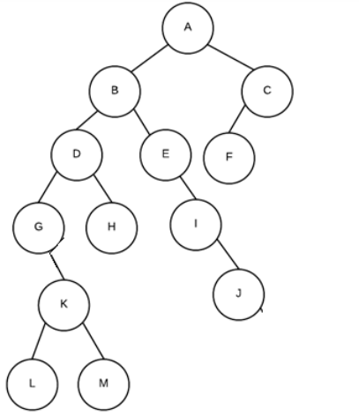

1. List the sibling(s) of D?
2. List all leaf nodes in the tree:
3. What is the height of the tree?
4. What is the height of subtree G?
5. What is the depth of E?
6. What is the height balance at D?
7. What is the path from A to M?
8. What are the leaf nodes of the sub-tree with root “D”?

# Question 2 (15 marks): Tree shape definitions



A

B

G

C

E

D

F

Explain is the above tree complete? (1 marks)

Explain is the above tree binary tree? (1 marks)

Explain is the above tree height balanced? (1 marks)

What is the pre-order traversal of the tree? (3 marks)

What is the in-order traversal of the tree? (3 marks)

What is the post-order traversal of the tree? (3 marks)

What is breadth-first traversal of the tree? (3 marks)

## Question 3 (15 marks): Graphs

The following diagram of adjacency list represents a graph.

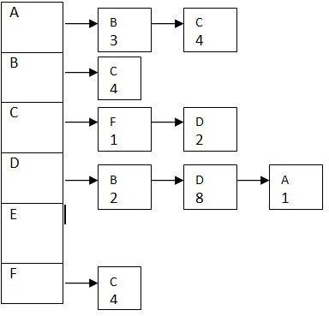

* 1. draw the above as a directed graph. Be sure to clearly show the “directions of edges”, and “edges weights” (10 marks)
  2. If the above graph was represented as an adjacency matrix instead of an adjacency list, what is the capacity of the data structure needed to represent the same graph? (5 marks)

# Question 4 (15 marks): Binary Heaps

Given the following array: {1, 3, 6, 5, 8, 7, 9, 2, 11, 4, 10}

1. Construct a max heap tree by inserting these number in the given order based on percolate up procedure. Show your full work step by step to get the full mark (8 marks). Note that whiteout step by step illustration and details you will get **Zero** mark.
2. Create a **maxheap** in place using the “heapify routine”. What is the final tree in array form. Show your work to get full marks (7 marks)

# Question 5 (15 marks):

Given the following array: {7, 3, 6, 5, 8, 17, 9, 2, 11, 4, 10}

1. Draw the binary search tree created by inserting each of the values in the array in the given order into a binary search tree (8 marks).
2. From constructed tree from part “a”, now remove node 17. How would be the final tree? (7 mark)

# Question 6 (10 marks): Graphs

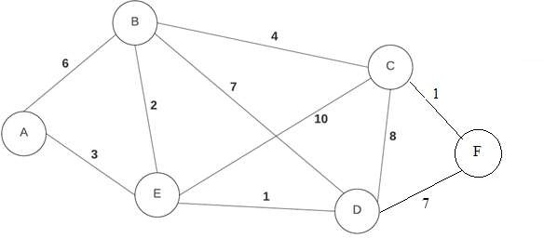

Given the graph on the right, Use Dijkstra’s shortest path algorithm to find the shortest path from A to every other node. Fill in the two table to show how you got result. The first table is for rough work. To get part marks, cross out values as they are modified but leave them in the table so that it is clear to me where you may have made a mistake. If your rough work only contains final rough work table, you won't get part marks if it is wrong. Note that you will get **zero** mark without illustration and details.

rough work Final table that includes final values

|  |  |  |  |
| --- | --- | --- | --- |
| **Vertex** | **Shortest distance to A** | **Previous Vertex** | **Known** |
| A | 0 |  |  |
| B | ◎ |  |  |
| C | ◎ |  |  |
| D | ◎ |  |  |
| E | ◎ |  |  |
| F | ◎ |  |  |

|  |  |  |  |
| --- | --- | --- | --- |
| **Vertex** | **Shortest distance to A** | **Previous Vertex** | **Known** |
| A |  |  |  |
| B |  |  |  |
| C |  |  |  |
| D |  |  |  |
| E |  |  |  |
| F |  |  |  |

**Final Result (2 marks)** From the above completed revised table, explain how the shortest path from A to F is defined? for example suppose your shortest path to D is A to B to C to D, put A-B-C-D for path entry.

# Programming: Please put all answers in the space provided. Question 7 (20 marks)

This question includes two parts “a”& “b”. Given the definition of a node and

binary search tree, you should complete the code of two functions in the next pages. Remember these functions must be defined based on concepts of BST. You can define extra functions if you needed.

class BST:

class Node:

# Node's init function

def init (self, value=None, left=None, right=None): self.value = value

self.left = left self.right = right

# BST's init function def init (self):

self.root = None

Use this page if you needed any extra space for parts “a” and “b” answers.

1. Complete the “**Min_Leafs_Value()**” function (10 marks):

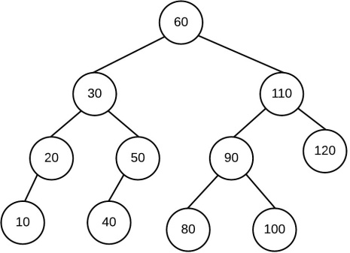This function starts traversing the tree from root, and returns the smallest value of all leaf nodes values.

For given the tree to the right, function returns 10.

## def Min_Leafs_Value(self):

1. 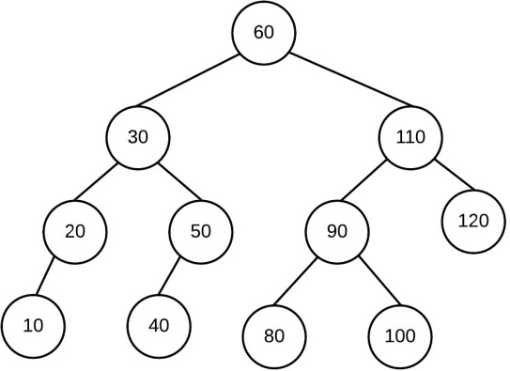**def min_of_subtree(self, value) (10 marks)**

This function starts traversing the tree from “root” and returns the smallest value in the subtree with root node containing value. If the node does not exist, function returns -1

Example, given the tree on the right:

**min_of_subtree (15)** returns -1 as 15 does not exist

**min_of_subtree ( 110)** returns 80

**min_of_subtree ( 50)** returns 40

**min_of_subtree ( 30)** returns 10

def find_min_of_subtree(self,value):